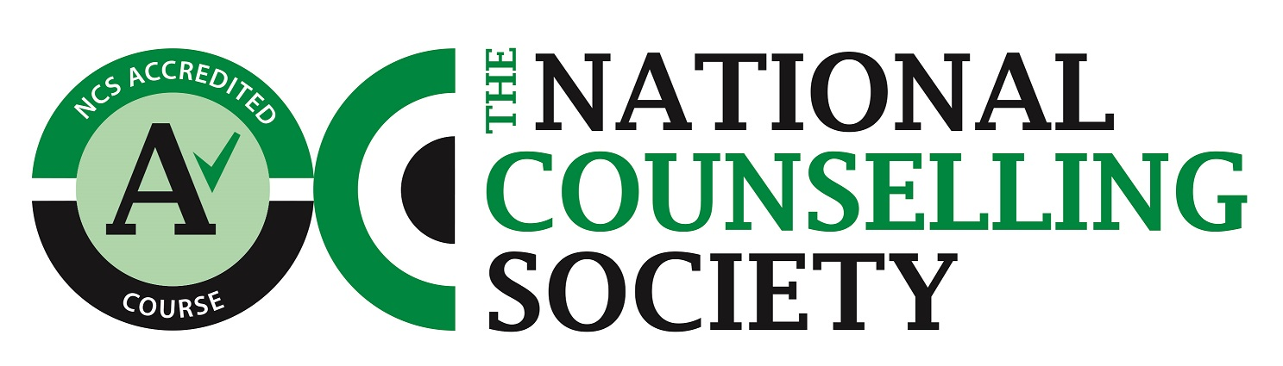

Course Overview - NCS Level 4 Diploma in Counselling

There are 7 units of study which are covered over the two years. Teaching comprises of presentation, demonstration, triad work and experiential exercises. Students are assessed by assignment, observation of skills, journal keeping, and engagement in the work.

Unit 1 Self Awareness in the Counselling Profession
This unit aims to enable learners to increase self-awareness by analysing and evaluating the impact that counselling theory and practice has on self and relationships, how self awareness is increased using theories and interaction with others, the role of feedback in evaluating strengths and areas for growth.
There is a requirement to have a minimum of 10 hours of personal therapy in both the first and the second year of this course.

Unit 2 Professional and organisational issues in Counselling
In this unit, learners will develop an understanding of the essential relationship between counsellors, as professionals, and the organisations and other people with which they may work. They will explore areas of potential conflict, especially through the existence of different ethical standards and principles. They will also reflect on the importance of: managing case work, utilising support from agency line managers and supervisors, ethical frameworks, professional bodies, working environment, contracting, record keeping, policies and legislation. This unit focuses on safety, standards, ethics, and professional practice.
Unit 3 Counselling Theory
In this unit, learners will analyse a range of therapeutic approaches, understanding the concepts and models for each, in order to develop abilities to integrate these approaches into practice and inform and empower their practice as a counsellor. Integrative approach - using Mindfulness based CBT, Gestalt, Person Centred, Attachment Theory, and Transactional Analysis.
Unit 4 Advanced Counselling Skills
Learners will demonstrate a range of advanced skills illustrating their development as practitioners. In addition, they will learn that counselling is a managed activity, with emphasis being given to the importance of opening and closing sessions and a series of sessions contracting, focus of work, the therapeutic relationship, pacing, immediacy, the client’s agenda, working with the implicit, endings
Unit 5 Research methodologies in Counselling
In this unit, learners will explore the importance of research in counselling. They will develop their research skills and will learn how to present findings. Demonstrating the importance and purpose of research, methods of research, and the application of research in counselling.

Unit 6 Counselling in a Diverse Society
In this unit, learners will explore the impact diverse culture and heritage can have on the client/counsellor therapeutic relationship in a multicultural society. They will also examine power issues within the counselling process stereotyping, culture, power dynamics, and the impact of these on the counselling relationship
Unit 7 Counselling Placement
Learners will complete this unit linked to supervised counselling placement practice. They will analyse how their theoretical approach has influenced their practice, and evaluate learning gained from supervision placement structure and policies, working agreements, record keeping, use of theory, use of supervision, professional development and personal growth.

